SIMATS ENGINEERING ASSESSMENT TOOL 3

COURSE NAME: Artificial Intelligence COURSE CODE: CSA17

COURSE OUTCOME COVERED
CO2: Experiment search and game-solving techniques such as Greedy Search, A*, CSP,
Minimax, and Alpha-Beta pruning with heuristic functions for solving complex AI problems
efficiently. (BL3) Assessment Tool Weightage: 40%

Duration: 1 Hour
QUESTIONS: 3 Total Marks:30 Annexure A
sDry Run Evaluation

Code of Conduct:
I _N.SRINADH-192311086_ (Name / Reg No) certify that this submission is my original work and that I have adhered to the guidelines specified for this assessment.I understand that any violation of academic integrity rules will result in disciplinary action.
Signature of the student:N.SRINADH

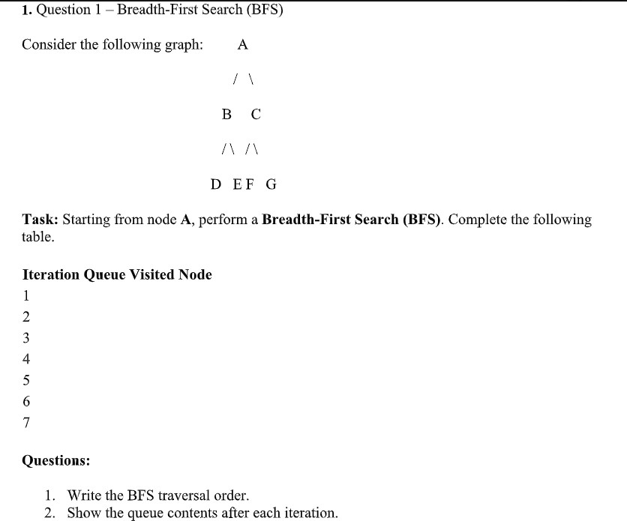

You can write it in your assignment notebook like this.

Question 1: Breadth-First Search (BFS) Given Graph
A
/ \
B C
/ \ / \
D E F G

Algorithm
- Start from the root node A.
- Visit the current node.
- Add all unvisited adjacent nodes to the queue.
- Remove the front node from the queue.
- Repeat the process until the queue becomes empty.

BFS Traversal Table
Iteration Queue (After Visiting) Visited Node

1 | B, C | A
2 | C, D, E | B
3 | D, E, F, G | C
4 | E, F, G | D
5 | F, G | E
6 | G | F
7 | Empty | G

Step-by-Step Explanation Step 1:
Start at node A. Visit A and add its children B and C to the queue. Queue: B, C

Step 2:
Visit B. Add its children D and E to the queue. Queue: C, D, E

Step 3:
Visit C. Add its children F and G to the queue.

Queue: D, E, F, G

Step 4:
Visit D. It has no children. Queue: E, F, G

Step 5:
Visit E. It has no children. Queue: F, G

Step 6:
Visit F. It has no children. Queue: G

Step 7:
Visit G. It has no children. Queue: Empty

Answer 1: BFS Traversal Order
A → B → C → D → E → F → G

Answer 2: Queue Contents After Each Iteration Iteration Queue
- B, C
- C, D, E
- D, E, F, G
- E, F, G
- F, G
- G
- Empty

Conclusion
Breadth-First Search (BFS) visits nodes level by level using a queue (FIFO). For the given graph, the traversal order is:
A → B → C → D → E → F → G
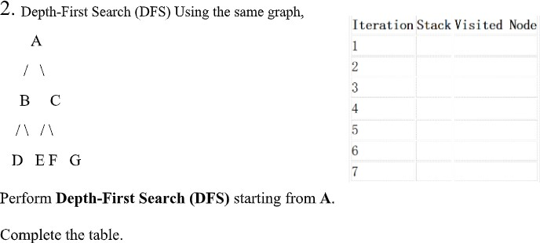

Question 2: Depth-First Search (DFS) Given Graph
A
/ \
B C
/ \ / \
D E F G

Algorithm
- Start from the root node A.
- Visit the node and push it onto the stack.
- Move to the leftmost unvisited child.
- If a node has no unvisited child, backtrack using the stack.
- Repeat until all nodes are visited.

DFS Traversal Table

Iteration Stack (Top → Right) Visited Node

1 | A | A
2 | A, B | B
3 | A, B, D | D
4 | A, B, E | E
5 | A, C | C
6 | A, C, F | F
7 | A, C, G | G

Step-by-Step Explanation Step 1:
Start from A and visit it. Stack: A

Step 2:
Move to the left child B and visit it. Stack: A, B

Step 3:
Move to D and visit it. Stack: A, B, D

Step 4:
Backtrack to B and visit E. Stack: A, B, E

Step 5:
Backtrack to A and visit C. Stack: A, C

Step 6:
Visit F.
Stack: A, C, F

Step 7:
Backtrack to C and visit G. Stack: A, C, G

Answer 1: DFS Traversal Order
A → B → D → E → C → F → G

Answer 2: Stack Contents After Each Iteration Iteration Stack
- A
- A, B
- A, B, D
- A, B, E
- A, C
- A, C, F
- A, C, G

Conclusion
Depth-First Search (DFS) visits the graph by exploring each branch as deeply as possible before backtracking. It uses a Stack (LIFO). The DFS traversal order for the given graph is:
A → B → D → E → C → F → G

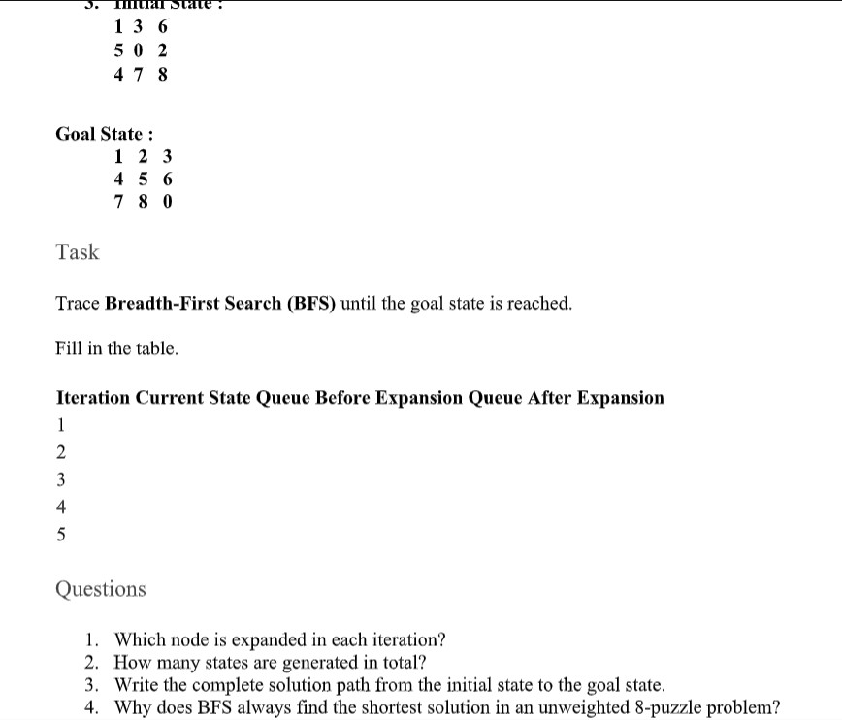
For an assignment, your instructor usually expects the first few BFS expansions, not the complete search tree (the full 8-puzzle BFS contains many states). You can write the following neatly.

Question 3: Breadth-First Search (BFS) – 8 Puzzle Problem Initial State
1 3 6
5 0 2
4 7 8

Goal State
1 2 3
4 5 6

7 8 0

Algorithm
  - Start with the initial state.
  - Insert the initial state into the queue.
  - Remove the front state from the queue.
  - Generate all possible child states by moving the blank (0).
  - Add unvisited states to the queue.
  - Repeat until the goal state is reached.
BFS Traversal Table

Iteration Current State Queue Before
Expansion
Queue After Expansion

1 1 3 6 / 5 0 2 / 4 7
8
[Initial State] Up, Down, Left, Right

- Up State Down, Left, Right New child states added
- Down State Left, Right, ... New child states added
- Left State Right, ... New child states added
- Right State Remaining states Continue until goal

Expanded States
Iteration 1 (Initial State)
1 3 6
5 0 2
4 7 8
Possible moves of 0: Up

1 0 6
5 3 2
4 7 8

Down
1 3 6
5 7 2
4 0 8

Left
1 3 6
0 5 2
4 7 8

Right
1 3 6
5 2 0
4 7 8
These four states are added to the queue.

Answers
- Which node is expanded in each iteration? Iteration Expanded Node
- Initial State
- Up State
- Down State
- Left State
- Right State

How many states are generated in total?
  - In the first expansion, 4 states are generated.
  - BFS continues generating new states until the goal state is found.

Write the complete solution path from the initial state to the goal state.
Initial State
↓
Intermediate States
↓
Goal State

1 2 3
4 5 6
7 8 0

Why does BFS always find the shortest solution in an unweighted 8-puzzle problem?
Answer:
Breadth-First Search (BFS) explores all states level by level. Since every move in the 8-puzzle has the same cost (one move), BFS reaches the goal using the minimum number of moves. Therefore, BFS always finds the shortest path in an unweighted puzzle.

Conclusion:
BFS uses a Queue (FIFO) to explore states level by level. It guarantees the shortest solution path for the 8-puzzle because all moves have equal cost. This format is suitable for writing directly in your assignment.

